**CTEC 22043**

**Object Oriented Programming**

**(2022/2023)**

Srirajitha.S

CT/2021/047

LAB WORKSHEET -03

Q1.

package Q1;  
  
public class Temperature {  
 private double celsius;  
  
 public Temperature() {  
 celsius = 0.0;  
  
 }  
  
 public Temperature(double celsius) {  
 this.celsius = celsius;  
  
 }  
  
 public double toFahrenheit() {  
 return (celsius * 9 / 5) + 32;  
 }  
  
 public double toCelsius() {  
 return celsius;  
 }  
  
 public void setCelsius(double celsius) {  
 this.celsius = celsius;  
 }  
  
 public void setFahrenheit(double fahrenheit) {  
 this.celsius=(fahrenheit-32)*5/9;  
 }  
}

package Q1;  
  
import java.util.Scanner;  
  
public class Main {  
 public static void main(String[] args) {  
 Scanner input=new Scanner(System.*in*);  
 System.*out*.println("Enter temperature in celsius");  
 double celsiusInput=input.nextDouble();  
 Q1.Temperature temperature=new Q1.Temperature(celsiusInput);  
 System.*out*.println("temperature in fahrenheit:"+temperature.toFahrenheit());  
 System.*out*.println("Enter temperature in F to convert to c");  
 double fahrenheitInput=input.nextDouble();  
 temperature.setFahrenheit(fahrenheitInput);  
 System.*out*.println("convert to c:"+temperature.toCelsius());  
 input.close();  
 }  
  
}

OUTPUT

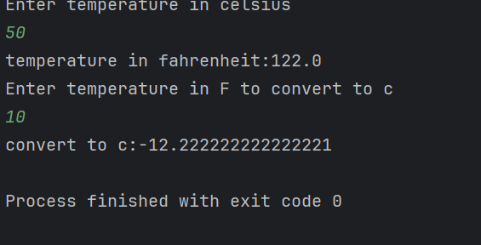

Q2.

package Q2;  
  
import java.util.Scanner;  
  
public class Main {  
 public static void main(String[] args) {  
 Scanner input = new Scanner(System.*in*);  
  
 System.*out*.print("Enter temperature in Fahrenheit: ");  
 double fahrenheit = input.nextDouble();  
  
 Temperature temp = new Temperature();  
 temp.setFahrenheit(fahrenheit);  
  
 System.*out*.println("Equivalent temperature in Celsius: " + temp.getCelsius());  
 }  
}

package Q2;  
  
  
public class Temperature {  
 private double celsius;  
  
 public void setFahrenheit(double fahrenheit) {  
 this.celsius = (fahrenheit - 32) * 5 / 9;  
 }  
  
 public double getCelsius() {  
 return this.celsius;  
 }  
}

OUTPUT

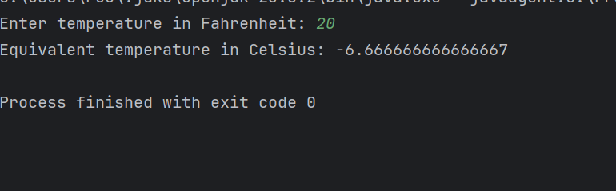

Q3.

package Q3;  
  
import java.util.Scanner;  
  
public class Main {  
 public static void main(String[] args) {  
 Scanner input = new Scanner(System.*in*);  
 System.*out*.println("Enter the inner radius of the circle:");  
 double innerRadius = input.nextDouble();  
 System.*out*.println("Enter the outer radius of the circle:");  
 double outerRadius = input.nextDouble();  
  
 if (innerRadius > outerRadius) {  
 System.*out*.println("Inner radius connot be greater than outer radius. ");  
  
 } else {  
 Circle outerCircle = new Circle(outerRadius);  
 Circle innerCircle = new Circle(innerRadius);  
  
 double Area = outerCircle.computeArea() - innerCircle.computeArea();  
 System.*out*.println("The area is: " + Area);  
  
 }  
 }  
}

package Q3;  
  
public class Circle {  
 private double radius;  
  
 public Circle(double radius) {  
 this.radius = radius;  
 }  
  
 public void setRadius(double radius) {  
 this.radius = radius;  
 }  
  
 public double computeArea() {  
 return Math.*PI* * radius * radius;  
 }  
  
 public double computeCircumference() {  
 return 2 * Math.*PI* * radius;  
 }  
}

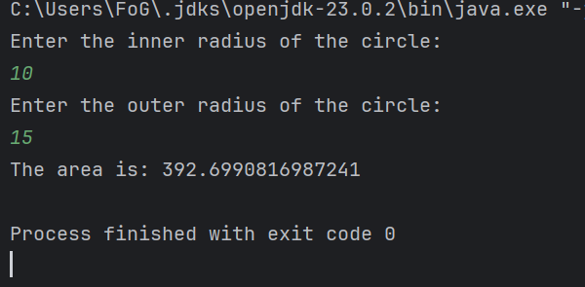

Q4.

package Q4;  
  
public class Main {  
 public static void main(String[] args) {  
 Owner owner = new Owner("John Doe", "123-456-7890");  
  
 Bicycle bike = new Bicycle("Giant", 21, owner);  
  
 bike.displayDetails();  
 }  
  
}

package Q4;  
  
public class Bicycle {  
 private String brand;  
 private int gearCount;  
 private Owner owner;  
 // Owner object instead of separate name and phoneNo  
  
 // Constructor  
 public Bicycle(String brand, int gearCount, Owner owner) {  
  
 this.brand = brand;  
 this.gearCount = gearCount;  
 this.owner = owner;  
 }  
  
 // Getters  
  
  
 public String getBrand() {  
 return brand;  
 }  
  
 public int getGearCount() {  
 return gearCount;  
 }  
  
 public Owner getOwner() {  
 return owner;  
 }  
  
 // Display bicycle details  
 public void displayDetails() {  
 System.*out*.println("Bicycle Brand: " + brand);  
 System.*out*.println("Gear Count: " + gearCount);  
 System.*out*.println(owner);  
 }  
}

package Q4;  
  
public class Owner {  
 private String ownerName;  
 private String phoneNo;  
  
 public Owner(String ownerName, String phoneNo) {  
 this.ownerName = ownerName;  
 this.phoneNo = phoneNo;  
 }  
  
 public String getOwnerName() {  
 return ownerName;  
 }  
  
 public String getPhoneNo() {  
 return phoneNo;  
 }  
  
 @Override  
 public String toString() {  
 return ("Owner: " + ownerName + ", Phone: " + phoneNo);  
 }  
}

OUTPUT

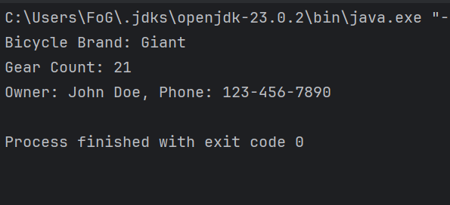

Q5.

package Q5;  
  
public class Main {  
 public static void main(String[] args) {  
 Lecturer lecturer = new Lecturer("Mr.Kesavan", "Object-Oriented Programming");  
  
 Course course = new Course("Object-Oriented Programming", "CTEC 22043", lecturer);  
  
  
 Student student = new Student("Yalini", "Information Communication Technology", "CTEC 22043");  
  
 System.*out*.println("Course: " + course.getCourseName() + " (" + course.getCourseCode() + ")");  
 System.*out*.println("Lecturer: " + course.getLecturer().getLecturerName());  
 System.*out*.println("Student: " + student.getStudentName() + " - " + student.getDegreeName());  
  
 }  
}

package Q5;  
  
public class Lecturer {  
 private String lecturerName;  
 private String courseTeaching;  
  
 public Lecturer(String lecturerName, String courseTeaching) {  
 this.lecturerName = lecturerName;  
 this.courseTeaching = courseTeaching;  
 }  
  
  
 public String getLecturerName() {  
 return lecturerName;  
 }  
  
 public void setLecturerName(String lecturerName) {  
 this.lecturerName = lecturerName;  
 }  
  
 public String getCourseTeaching() {  
 return courseTeaching;  
  
 }  
}

package Q5;  
  
public class Lecturer {  
 private String lecturerName;  
 private String courseTeaching;  
  
 public Lecturer(String lecturerName, String courseTeaching) {  
 this.lecturerName = lecturerName;  
 this.courseTeaching = courseTeaching;  
 }  
  
  
 public String getLecturerName() {  
 return lecturerName;  
 }  
  
 public void setLecturerName(String lecturerName) {  
 this.lecturerName = lecturerName;  
 }  
  
 public String getCourseTeaching() {  
 return courseTeaching;  
  
 }  
}

package Q5;  
  
public class Student {  
 private String studentName; private String degreeName;  
 private String courseFollowing;  
  
 // Constructor  
 public Student(String studentName, String degreeName, String courseFollowing) {  
 this.studentName = studentName;  
 this.degreeName = degreeName;  
 this.courseFollowing = courseFollowing;  
 }  
  
 public String getStudentName() {  
 return studentName;  
 }  
  
 public void setStudentName(String studentName) {  
 this.studentName = studentName;  
 }  
  
 public String getDegreeName() {  
 return degreeName;  
 }  
  
 public void setDegreeName(String degreeName) {  
 this.degreeName = degreeName;  
 }  
  
 public String getCourseFollowing() {  
 return courseFollowing;  
 }  
  
 public void setCourseFollowing(String courseFollowing) {  
 this.courseFollowing = courseFollowing;  
 }  
}

OUTPUT

